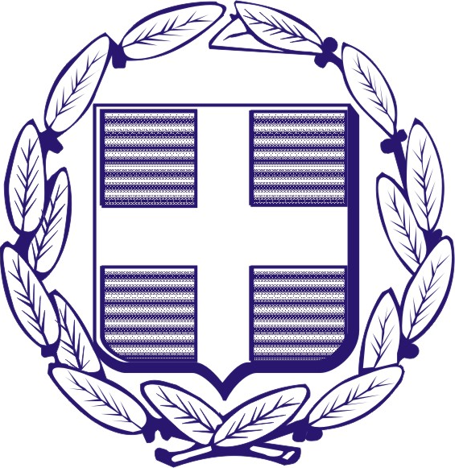  Education and Culture  Lifelong Learning Programme  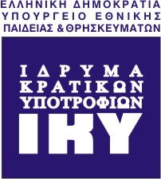 | 

Contact Seminar Grundtvig – Leonardo Da Vinci

«Validation of non-formal and informal learning for adult trainees/learners in connection with ECVET and EQF»

20-24 September 2009

Hotel Panorama
Kato Galatas, Chania, Crete
Greece

Sunday 20th of September
17:00 onwards | Registration - Preparation of the European fair
19.00 | Opening of the seminar – Welcome cocktail dinner
Monday 21st of September
09.30-10.00 | The Grundtvig sectoral programme  Georgia Sarri, IKY, Grundtvig/Study Visits Coordinator  Niki Paraskevopoulou, IKY, Grundtvig/Study Visits  The Leonardo da Vinci sectoral Programme  Maria Xarhoulakou, IKY, LdV Unit
10.00-10.30 | Fiona Croke, Project Officer Transnational Mobility, Lifelong Learning Programme, Leonardo da Vinci National Agency Ireland  “EQF and ECVET ‘access transfer and progression’  A European and Irish Perspective”
10.30-11.00 | Esther Seivane, Member of the New Grundtvig Actions Working Group  “Tips and ideas for successful projects”
11.00-11.30 | Discussion – Comments - Questions
11.30-12.00 | Coffee break
12.00-12.15 | Introduction to the working groups
12.15-13.30 | Parallel Working Groups (4 totally, max 15 participants each)
13.30-15.00 | Lunch
15.30-17.00  17.00-17.30  17.30-18.30 | Parallel Working Groups (4 totally, max 15 participants each)  Coffee break  Parallel Working Groups (continued)
19.00 | Departure from the hotel for a guided tour to the city of Chania
21.00 | Dinner (in a traditional tavern in Chania)
23.00 | Departure to the Hotel
Tuesday 22nd of September
9.30-11.00 | Presentations of successful Leonardo da Vinci and Grundtvig projects  - Yiannis Bakouros, Ass. Professor, Management of Technology Research Lab, University of Western Macedonia  “Maintenance Training in EU: Lessons learnt from a Leonardo project”  - Nikos Katsiadakis, Project Manager, Knowledge Management Researcher, Thessaloniki Technology Park, Management & Develpoment Corp. SA  “The history of two innovative Leonardo pilot projects supporting knowledge & creativity”  - Nikos Manouselis, Researcher, Greek Research and Technology Network SA  “Setting up a successful Leonardo Project: Some Reflections”  - George C. Domouchtsis, Second Chance School of Serres  Project “A new chance - Digital technology”, Grundtvig Learning partnership  - Dimitra Lelingou, Hellenic Physics Society  Project “Exploring Science as Culture”, Grundtvig Learning partnership
11.00-11.30 | Coffee break
11.30-13.30 | Parallel Working Groups (4 totally, max 15 participants each)
13.30-14.30 | Lunch
15.00-16.00  16.00-16.15  16.15-17.00 | Parallel Working Groups (4 totally, max 15 participants each)  Coffee break  Parallel Working Groups (continued)
17.30 | Departure from the hotel for a guided tour to the city of Rethymnon
20.30 | Dinner (in a traditional tavern in Rethymnon)
23.00 | Departure to the hotel

Wednesday 23rd of September
09.30-11.00  11.00-11.20  11.20-12.00 | Presentation of the projects drafted  Coffee break  Presentation of the projects drafted (continued)
12.00-12.30 | Closure of the seminar
13.00-14.30 | Lunch
15.00 | Departure from the hotel for a guided tour to famous historical places in the Prefecture of Chania
19.30 | Departure from the city of Chania to the hotel
20.30- | Dinner (traditional Cretan night under the sound of Greek and Cretan music and dances)
Thursday 24th of September
Departure of the participants

The working language will be English.

